Arctic mosquitoes Feb 2018

**Question and hypotheses**

Overarching question: What determines the number and size of mosquitoes emerging from ponds?

Some possibilities:

1. Females oviposit in habitats that have a high probability of survival for their offspring. For example, the edges of dried ponds that are likely to be wet the following year. **Ponds with more eggs have more larval mosquitoes and have the largest number of emerging adults.**

This seems very likely, given the data I have so far. The ponds with the most larvae tend to have the largest number of emerging mosquitoes. Moreover, those places seem to have the largest mosquitoes (not always, but often).

1. Ponds vary in the density of early instar mosquitoes. **Ponds with higher densities of early instar mosquitoes have greater per-capita mortality due to competition, and have about the same number of emerging mosquitoes as ponds with lower densities of early instars.**

I see some evidence of negative density dependence in ponds, especially when looking across the same ponds in different years. But it still seems that there is undercompensation in most cases (more mosquitoes = more mosquitoes).

1. Ponds vary in terms of the quality and quantity of food for mosquitoes (microorganisms on detritus and vegetation). **Ponds with more mosquito food have larger emerging adults, furthermore resource competition is alleviated in ponds with more food (less or no density dependent mortality)**

I have basically no data to answer this at the moment, but I think it is really important, and should be a focus of the 2018 field season.

1. Ponds vary in aquatic predator density. **More mosquitoes emerge in ponds with less predators.**

Given the data I have so far, I don’t see strong evidence for this.

1. Some ponds are warmer than others, affecting mosquito development time. **More mosquitoes emerge from warmer sites because they grow faster, and have less days to experience mortality from predators.**

I have some data to look at this, but have not had time to do it yet.

**Data figures**

1. **Are the places with the most # larval mosquitoes consistent across years?** 
   * Avg number of early instar mosquitoes (1st sampling date at ponds)

**Maybe. But 2012 lowest abundance in all cases.**

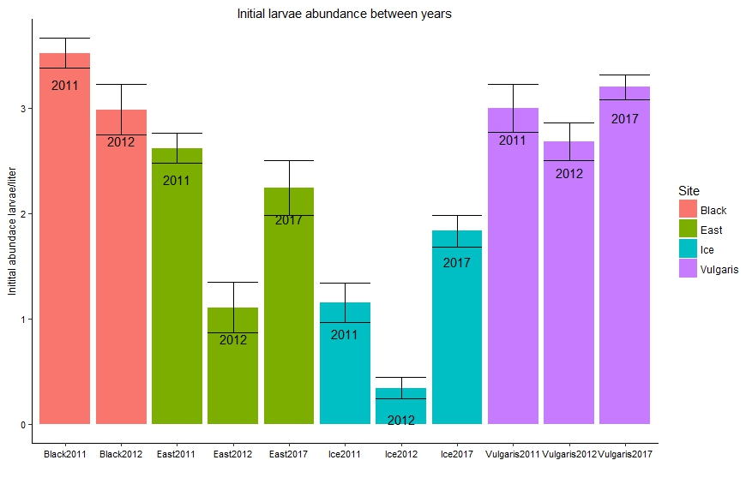

1. **Do ponds with more early instar mosquitoes have more pupae?**

**Yes. More early instars = more pupae = more emerging adults**

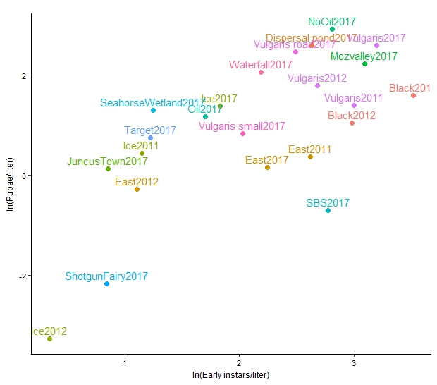

1. **Do ponds with more early instar mosquitoes have more emerging mosquitoes?**
   * Densities @ first sampling vs. cumulative # from emergence traps

**Maybe. Either no relationship, or positive**

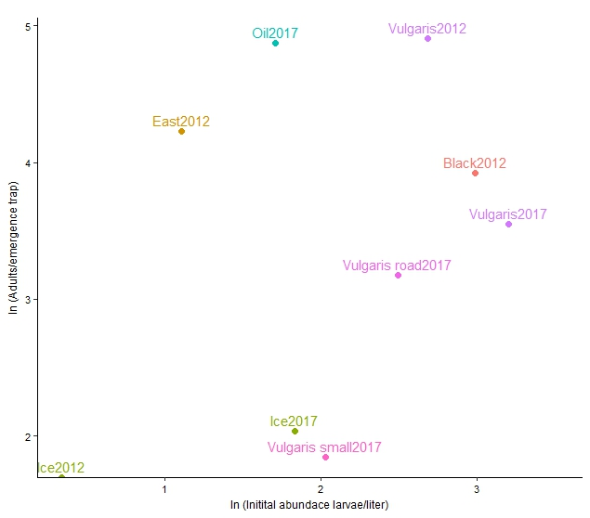

1. **Do ponds with greater densities of early instars have smaller emerging mosquitoes?**

**No it’s the opposite…when there’s more larval mosquitoes they are bigger**

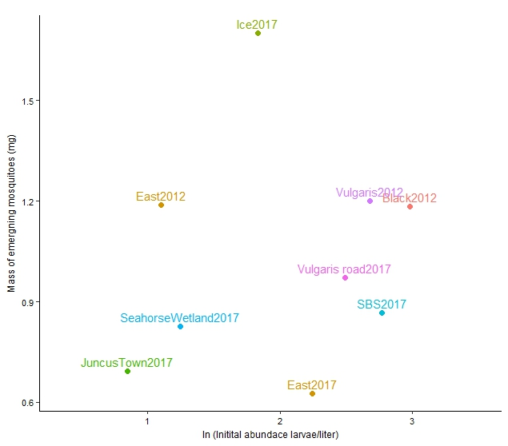

1. **Are the places with the most # beetles consistent across years?**
   * Used avg beetle densities across dates after beetles started showing up in ponds

**Maybe. But again, 2012 lowest abundance in all cases.**

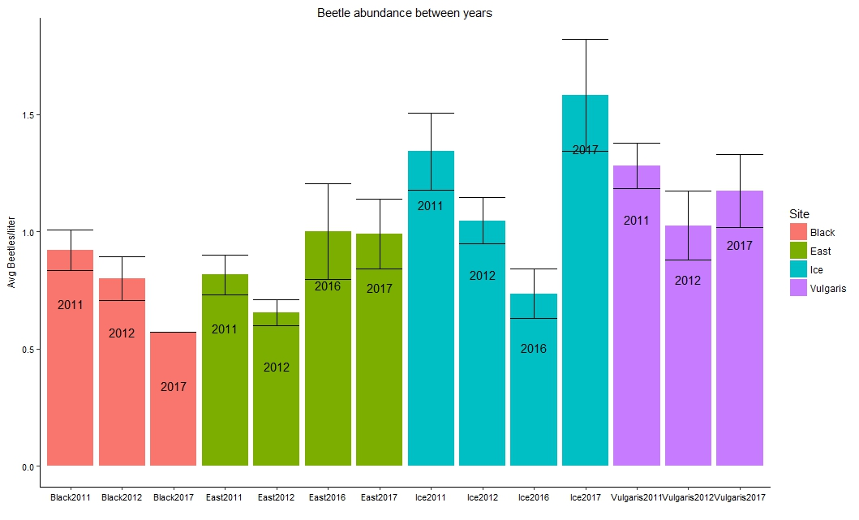

1. **Do ponds with higher densities of early instar mosquitoes have more beetle predators?**
   * Densities early instars @ first sampling (before there are beetles) vs. avg density of beetles

**Interesting! No relationship across ponds, but within ponds, in years with more mosquitoes there are more predators**

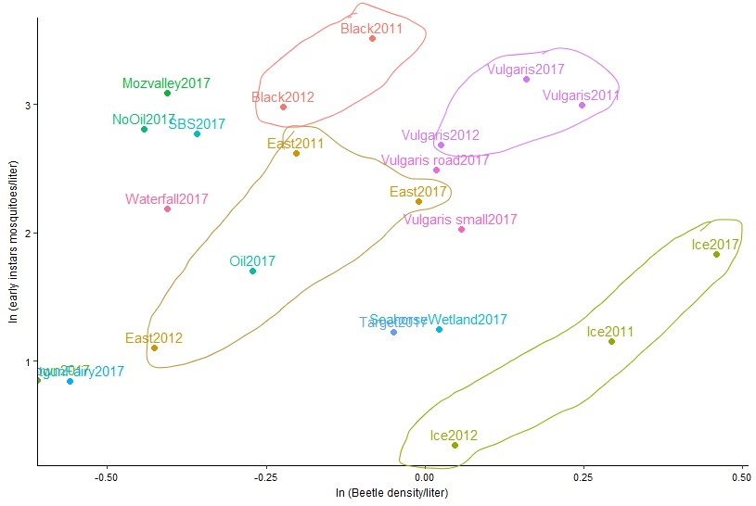

1. **Do ponds with greater densities of predators have fewer emerging mosquitoes?**
   * Avg predator densities vs. cumulative # from emergence traps

**No. Predator abundance in pond alone does not affect density of emerging mosquitoes**

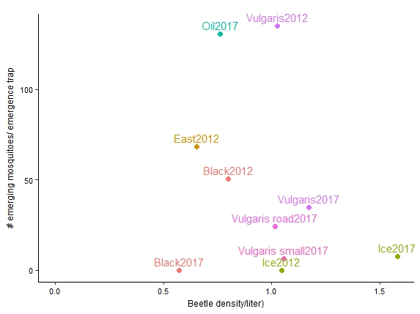

1. **Do ponds with higher densities of larvae have higher per-capita mortality?**

Within the same ponds (looking across years) steeper slopes seem to be correlated with higher initial densities. BUT this doesn’t hold in comparing across ponds exactly. For example, Black and East have higher per capita mortality than Vulgaris even though initial densities are comparable.

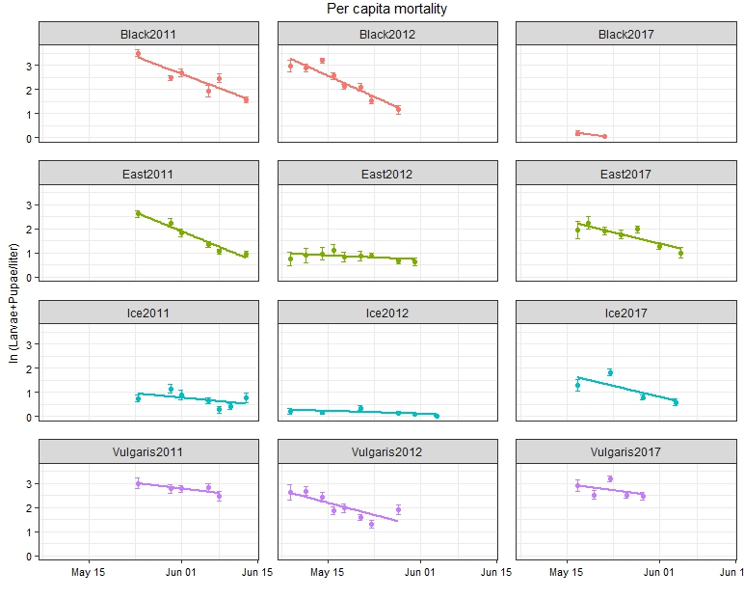

1. **Do ponds with higher densities of larvae have higher per-capita mortality?**

I extracted the slopes from the above figure (+11 other ponds I have same data for). I regressed slope (per capita mortality) vs. the number of mosquitoes in the pond on the 1st sampling date (not exactly N(0) but my best estimate for now)

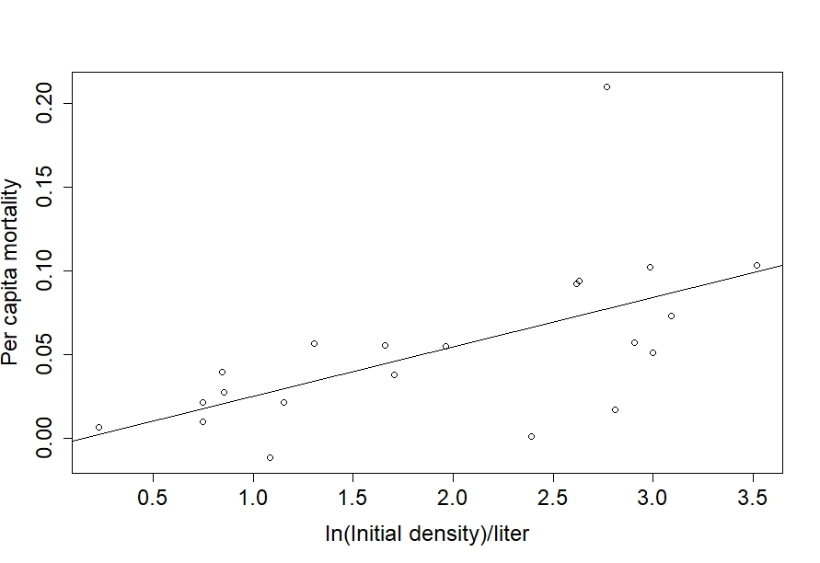

1. **Do ponds with higher densities of larvae have slower relative growth rate?**

**This graph doesn’t answer this question….I’ve only gotten this far. (Also have these data from ~10 more ponds)**

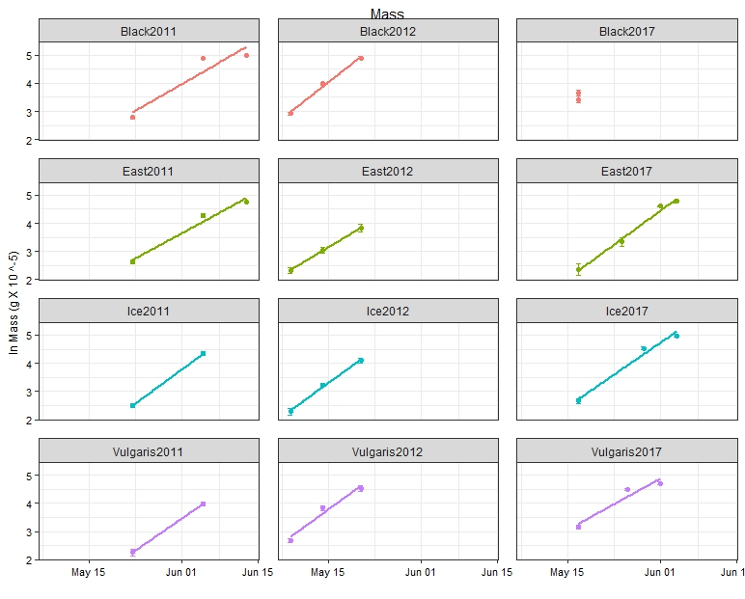

**Pond temperatures during larval development**

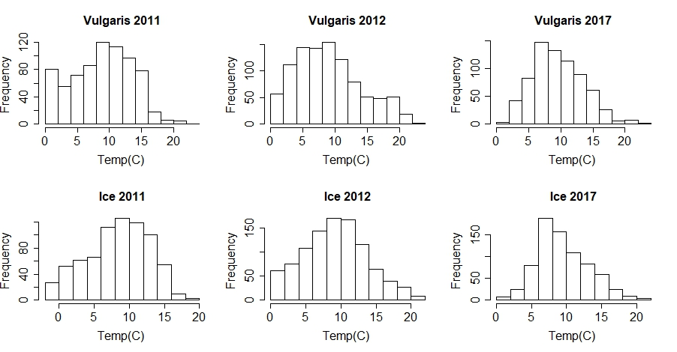

**A few ideas for this summer**





